NIC information for my computer from ipconfig /all

Part 1 Step 4

What is significant about the contents of the destination address field?

Since this is a broadcast and not a specific communication the destination field does not list a singular specific MAC address and instead that it is a broadcast to all devices connected to the switch.

Why does the PC send out a broadcast ARP prior to sending the first ping request?

It sends out an ARP request to tell the network who it is looking for and who it is so that an ARP lookup can happen and the ping can reach the correct destination.

What is the MAC address of the source in the first frame?

f0:1f:af:50:fd:c8

What is the Vendor ID of the source NIC in the ARP reply?

30:46:9a or Netgear

What portion of the MAC address is the OUI?

First six hex numbers

What is the NIC serial number of the source?

50:fd:c8 in the ARP request 99:c5:72 in the reply

Part 2

What is the IP address of the PC default gateway?

10.4.32.1

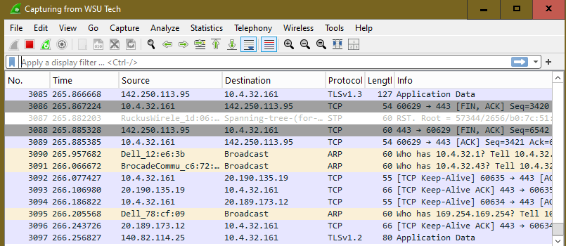  
What is the MAC address of the PC NIC?

8c:ec:4b:78:f4:2e

What is the default gateway’s MAC address?

60:9c:9f:c6:72:50

What type of frame is displayed?

IPv4

What is the source IP address?

10.4.32.161

What is the destination IP address?

10.4.32.1

What do the last two highlighted octets spell?

Fghi

What device and MAC address is displayed as the destination address?

The PC is the destination – 8c:ec:4b:78:f4:2e

REMOTE PING

In the first echo what is the source/destination MAC addresses?

8c:ec:4b:78:f4:2e

60:9c:9f:c6:72:50

What are the source and destination IP addresses contained in the data field?

10.4.32.161

184.31.100.119

Why has the MAC address stayed the same but the IP changed?

The MAC address is the same as it is a remote IP meaning the ping needs to reach the switch and go through the default gateway which keeps the same MAC address but goes further to a ip address outside the system.

What does the preamble contain?

The preamble has some data and bits to tell the NIC that the frame is starting, how long it is and how to process it?